Case History

Project CF 208, Salt Lake City Building

Industry Building Residential

Location Kolkata

Year of Completion 2006

Consultant Mr. Sanjiv J. Parekh,
M/S S.P.A. Consultants
53,Justic Chandra Madhab Road
Kolkata-20

Product Nitowrap EP (CF), Conbextra EP10, Lokfix S, Nitowrap 410, Nitoprime 30,Rendroc FC

Applicator M/S NuTech Engineering

197, Park Street, Kolkata-17

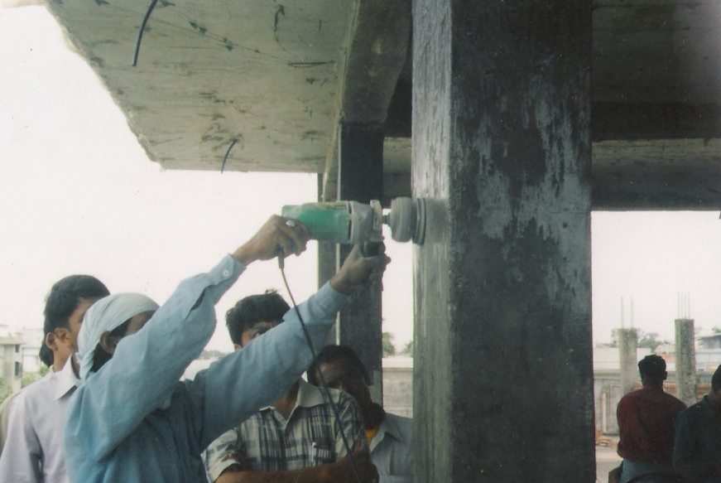

Surface preparation & cleansing

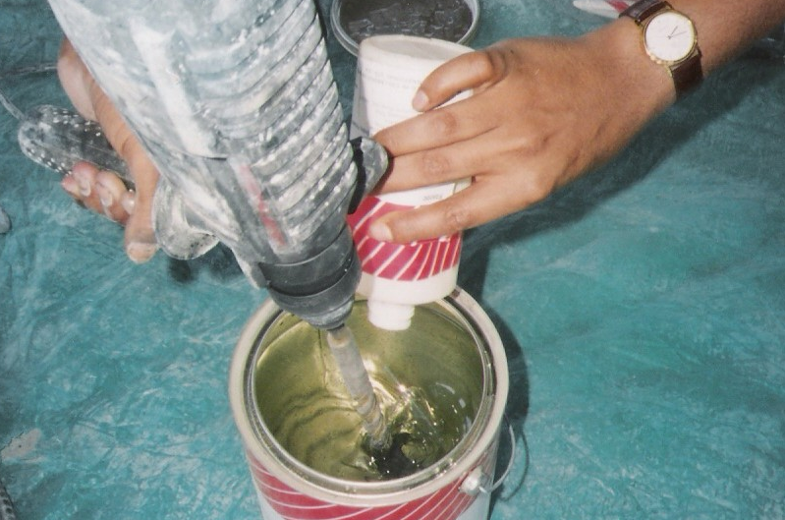

Mixing

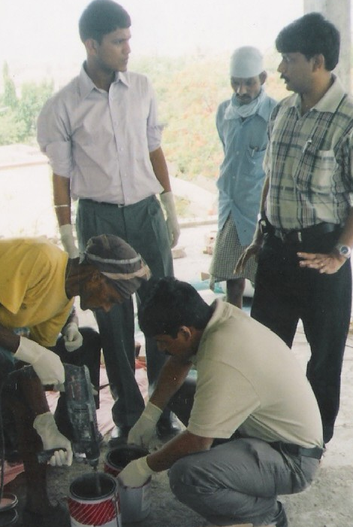

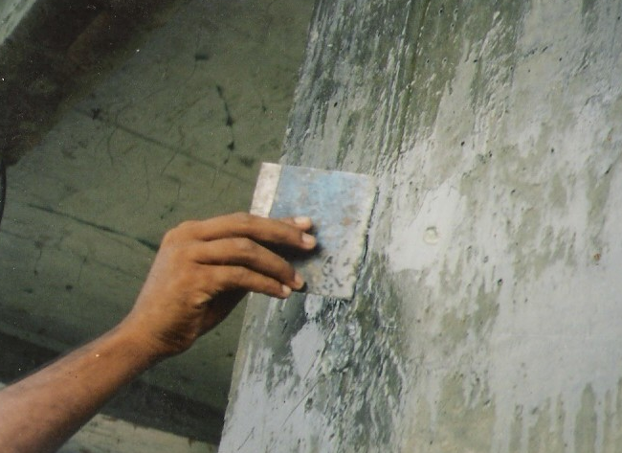

Surface Preparation

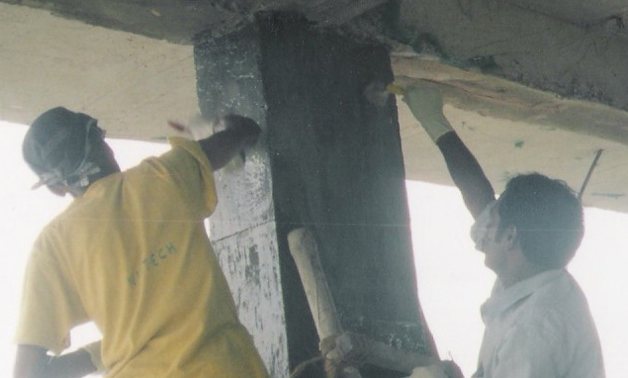

Application Of Nitoprime 30

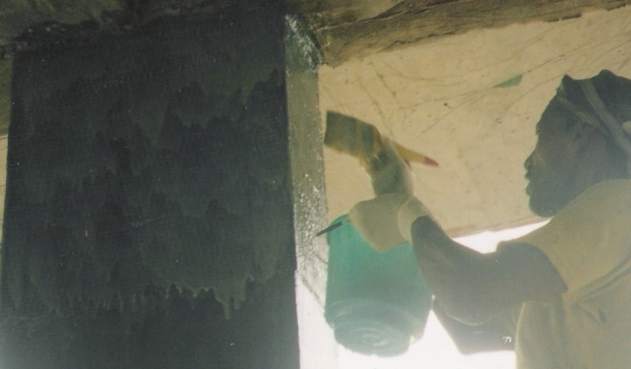

Application Of Nitowrap 410

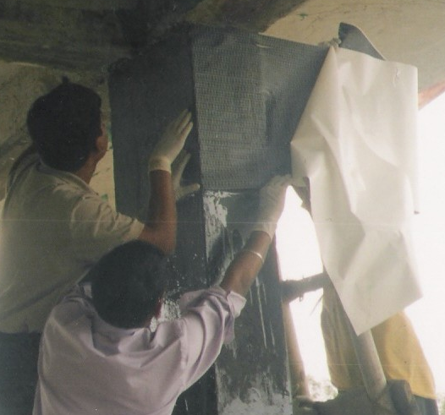

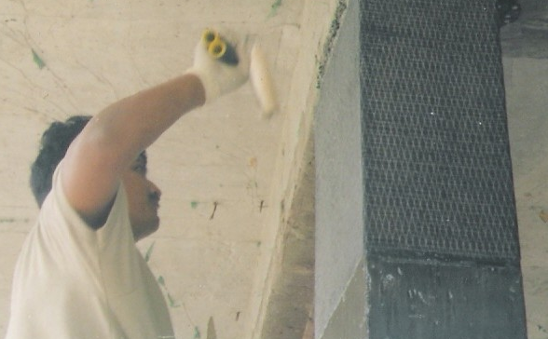

Rolling

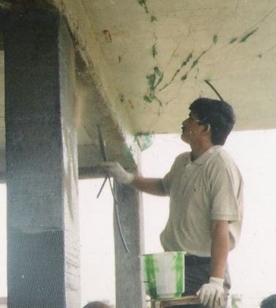

Spraying Sand

Customer Requirement

An residential building at Salt Lake City a G+4 structure was investigated by a renowned consultant M/S S.P.A Consultants by the owner of the building and all the columns were tested through NDT tests like Ultra sonic pulse velocity, rebound hammer test etc, and 17 numbers of columns were identified in the building which were having the compressive strength below M10 as per the report submitted by the testing agency, These results were found to be below acceptable engineering parameters and the quality of the cement used was found to be inferior.
The client requirement was to counter this problem and offer him the suitable technology/solution.
The owner was not interested for time consuming conventional techniques.
A reference was made to FOSROC CHEMICALS (I) PVT LTD, to suggest a suitable technique.
After discussions with the consultant it was finally decided that Nitowrap EP (CF) carbon fiber wrapping system is to be carried out.

Proposed Solution

- The 17 columns were marked and thoroughly examined for undulations.
- Columns were thoroughly cleaned by blowers and undulations were properly taken care of by mechanical chipping machines to make the surface smooth and even by the use of Lokfix S to fill various gaps.
- The nozzles were fixed thought the column and were grouted after proper mixing with mechanical mixer using Conbextra EP10 to make the column strong and void free.
- A layer of Rendroc FC was applied to make the surface smoother, so that the fiber will be thoroughly adhered to the column surface.
- A layer of Nitoprime 30 was then applied and subsequently allowed to dry for 12 hours.
- Nitowrap EP (CF) carbon fiber wrapping system was then applied to columns with prior application of Nitoprime 410 ensuring proper over lapping as per the technical datasheet and layer of saturant Nitoprime 410 is applied.
- Before the saturant starts to dry completely a layer of sand is sprayed/sprinkled to provide a mechanical key that will help for plastering.

